**Final Report**

**Click Sensor Hub**

**Project Manager: Alfonso de la Morena**

**Dylan Dean, Mohamed Sghari**

**Texas State University**

**Ingram School of Engineering**

**SPONSOR NXP**

**6501 W William Cannon Dr**

**Austin, TX 78735**

**3/27/2019**



|  |  |  |  |
| --- | --- | --- | --- |
| **Revision History** | | | |
| **Version** | **Date** | **Description** | **Author** |
| 0.10 | 3/28/2019 | Initial read and section assignment | Alfonso |
| 0.11 | 3/29/2019 | Added new diagrams | Alfonso |
| 0.20 | 3/30/2019 | Completed section 4 | Alfonso |
| 0.21 | 3/30/2019 | Completed part of section 5 | Alfonso |
| 0.30 | 3/30/2019 | Drafted sections 6, 7, 8, 9 and 10 | Alfonso |
| 0.31 | 3/30/2019 | Worked with Alfonso on sections | Dylan |
| 0.32 | 3/30/2019 | Completed validation and testing section | Dylan |
| 0.33 | 3/31/2019 | Updated all figures and diagrams | Dylan |
| 0.34 | 3/30/2019 | Completed sections 6, 7, 8, 9 and 10 | Alfonso |
| 0.40 | 3/31/2019 | Proof reading mistakes | Dylan |
| 0.41 | 3/31/2019 | Made checklist adds and subtractions | Dylan |
| 0.42 | 4/19/2019 | Edits Requested by Sponsor added | Dylan |
| 0.43 | 4/19/2019 | Edits Requested by Faculty added | Dylan |
| 0.45 | 4/20/2019 | Completed Sections | Mohamed |
| 0.50 | 4/22/2019 | Programed all table and figure names | Alfonso |
| 0.51 | 4/22/2019 | Checked all table and figure references | Alfonso |
| 1.0 | 4/26/2019 | Final Edits | Alfonso |

# Overview

## Executive Summary

Working with our sponsor, Dr. Kemp at NXP, and our faculty advisor, Dr. William Stapleton at Texas State University, we have designed an add-on board for the FRDM-KL46Z (a development platform built on the Arm® Cortex®-M0+ processor). Our board will convert 24 out of the 64 pins available in the KL46Z to 4 MikroBus Standard sockets. These 4 sockets facilitate communication with 600+ Click Sensors. The user simply connects the KL46Z to our board, connects any combination of Clicks into the sockets and is ready to begin developing.

Our team is comprised of 3 members:

* Project Manager: Alfonso de la Morena (Computer Engineering)
* Dylan Dean (Micro – Nano Devices)
* Mohamed Sghari (Micro – Nano Devices)

Despite the project not meeting all its initial goals. It is still considered a success in some respects that it set out to achieve. In summary below:

* The project set out to create a board that allowed a FRDM-KL46Z board to interface with any of 4 different MikroBUS standard sockets and it achieved this goal.
* The project set out to create a board that could power a FRDM-KL46Z board and 4 different MikroBUS devices (at 3.3V or 5V) and it achieved this goal.
* The project set out to create a website to display all code, hardware files and user guides necessary and it achieved this goal.
* The project set out to create functional code for all 10 selected Click sensors to interface simultaneously with the FRDM-KL46Z via our board and it failed this goal.

## Abstract

The Click Sensor Hub team has the goal of creating a PCB that simplifies the process of connecting multiple devices that follow the MikroBUS standard to NXP’s FRDM-KL46Z board. Our design accomplishes this by sharing lines across the 5 supported communication channels. For example, the SPI channel can share MOSI, MISO and CLK pins. This means we can condense what would have been 16 (4x4) pins to connect four channels to 7 (3+4) pins.

Contents

1 Overview 3

1.1 Executive Summary 3

1.2 Abstract 3

2 List of Figures 5

3 List of Tables 5

4 Problem Description 6

5 Progress Towards A Solution 7

5.1 Design Decisions 7

5.2 Design Approach 8

5.3 Project Approach 10

5.4 Engineering Standards 11

5.5 Progress Towards Goals 11

5.6 Verification 11

5.7 Characterization Results 12

5.8 Deficiencies 16

5.9 Iterations and Redefinitions 17

6 Constraints 17

6.1 Budgetary 17

6.2 Design Feasibility 17

6.3 Manufacturability 18

6.4 Maintainability 18

6.5 Environmental 18

6.6 Health and Safety 18

6.7 Social 18

7 Budgets 18

8 Work Schedule 20

9 Personnel Interactions 21

9.1 Teamwork 21

9.2 Mentorship 22

10 Ethics 22

11 Summary & Conclusions 23

12 Discussion 23

12.1 Academic Preparation 23

12.2 Lessons Learned 24

12.3 Soft Skills 24

12.4 Schedule Deviations 24

12.5 Staffing 24

12.6 Final Observations 25

13 Acknowledgments 25

14 References 25

# List of Figures

**Fig. 1.** System level diagram of Click Sensor Hub. Blocks highlighted in yellow were designed for this project. 6

**Fig. 2.** Initial PCB Design with MikroBUS Sockets in all corners. Blocks highlighted in yellow were designed for this project. 7

**Fig. 3.** Click Sensor Hub removed components in final iteration. Removed components for final iteration of PCB design are highlighted in red. 8

**Fig. 4.** How FRDM-KL46Z Mbed GUI handles Click and socket selection. 9

**Fig. 5.** Loop for FRDM-KL64Z to switch between the different Click Sensors attached to the Click Sensor Hub board. This is meant to approach a simultaneous behavior in which all the Clicks are running at the same time when the switches from one Click to the next 10

**Fig. 6.** FRDM-KL46Z pin readings from 4 MikroBUS standard sockets abstraction. The yellow boxes highlight all the pin assignments that were necessary for writing the code in the Mbed compiler. 11

# List of Tables

**Table 1.** Applicable Standards 11

**Table 2.** Individual Click Validation. Detailing the test procedures and the respective results. 12

**Table 3.** Click Sensor Hub Board Validation. Detailing the test procedures and the respective results. 14

**Table 4.** Stretch Goal Website Validation. Detailing the test procedures and the respective results. 16

**Table 5.** System Deficiencies Accompanied by Suggest Solution and Estimated Completion Time 16

**Table 6.** Parts Order January 25th, 2019 19

**Table 7.** Parts Order February 23rd, 2019 19

**Table 8.** PCB Orders 20

**Table 9.** Click Sensor Hub work schedule timeline 20

**Table 10.** Courses objectives as defined in the Statement of Work. 23

**Table 11.** General tests and results of objectives described 23

**Table 12.** Courses teammates agreed were most useful for completing the Click Sensor Hub project 24

# Problem Description

The Click Sensor Hub project was created with the intention of being a useful tool that students in Dr. Stapleton’s Microprocessors class at Texas State University could use for the many labs that course requires. The designed PCB board creates a bridge between the FRDM-KL46Z (the board students are given at the beginning of the semester) and 4 MikroBUS standard sockets. The MikroBUS standard, which is discussed in more detail in the Technical Spec Document, is used to connect what are known as Clicks.

The Clicks are simple devices meant for prototyping and adding sensor capabilities to microprocessors. To communicate, Clicks use SPI, UART, Analog, PWM and/or I2C. All power is handled by the board. The Click Sensor Hub board allows the students to focus on the code and leave all the complicated wiring to the hardware. **Fig. 1** below shows a high-level diagram of how the Click Sensor Hub board connects.

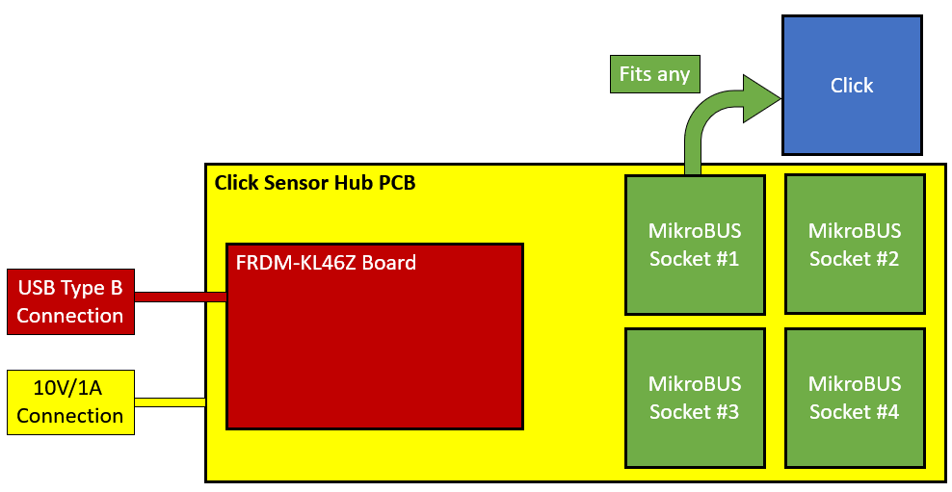

**Fig. 1.** System level diagram of Click Sensor Hub. Blocks highlighted in yellow were designed for this project.

# Progress Towards A Solution

## Design Decisions

There have been many iterations of the project. Most have been hardware iterations but there have been some software changes as well. Starting with the hardware decisions, the initial design for the board had the FRDM-KL46Z in the middle and a MikroBUS socket in each of the corners. A schematic for the old design can be seen in **Fig. 2** below.

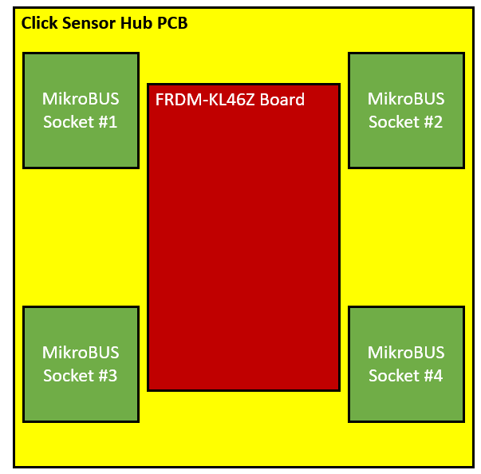

**Fig. 2.** Initial PCB Design with MikroBUS Sockets in all corners. Blocks highlighted in yellow were designed for this project.

The faults with this approach were mostly due to the layer constraints for the PCB. It was decided early on that the PCB would have a maximum of 2 layers. For the initial design, this caused many wiring issues with wires taking very long detours to reach their destination. This eventually led to the final design which is what was shown in **Fig. 1**. The MikroBUS sockets being in proximity greatly simplified the wiring.

In addition to changing the layout of the PCB, there have also been changes to ICs included in the PCB board. Initially, the Click Sensor Hub board included a 3:8 encoder for the interrupts, a 2:4 encoder for the SPI channels and 1 UART to 2 SPI chips for the UART channels in each of the MikroBUS sockets. This was later removed due to programming and soldering issues the team ran into. In the new version of the Click Sensor Hub board, the 2:4 encoder for the SPI CS was replace with 4 digital out pins, the 3:8 encoder for the interrupter was removed and the a 1 UART to 2 SPI chips were replaced with 4 unique UART channels. An illustration of what was removed can be seen below in **Fig. 3**.

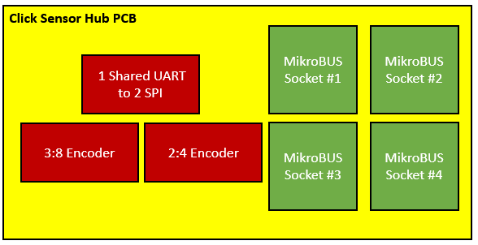

**Fig. 3.** Click Sensor Hub removed components in final iteration. Removed components for final iteration of PCB design are highlighted in red.

The software also went through many iterations. Initially, the design had many individual classes for each of the Clicks. This was done with the goal to creating a Click Sensor Hub library that could be included in the programs the students made. However, this approach ended up taking too much memory and was unnecessary for what the project meant to achieve. Instead, the Mbed code was simplified to one or two functions per click. This shows anyone who sees the code how to assign the correct pins and what functions to use to communicate in the Mbed compiler.

## Design Approach

The design approach was mostly accomplished thanks to the input and advice of Dr. William Stapleton and Dr. Kevin Kemp. The Click Sensor Hub team meets regularly with them and discusses what decisions they have made throughout the week as well as the results they have produced.

The three engineering students working on the project meet every Monday and Wednesday at the lab to test boards and code in the Texas State University labs. It is important to test each of the decisions made due to products not always performing as the documentation says. A good example is the work done on the Alcohol click. The Alcohol Click measures alcohol levels in the air with analog communication. Before connecting the Click to the board, the team met at the lab and tested the output voltages of the click sensor and found that it produced a 4V reading, which would have fried the FRDM-KL46Z. This example is one of the reasons for which every click is tested for voltage levels before being connected to the board.

The general approach for the Mbed code was to approach each of the clicks individually. The code has a switch function that can select any of the clicks and perform the respective task. The only argument that needs to be specified is the Socket and Click Selection. An example of how the GUI handles this approach can be seen in ***Fig. 4***.

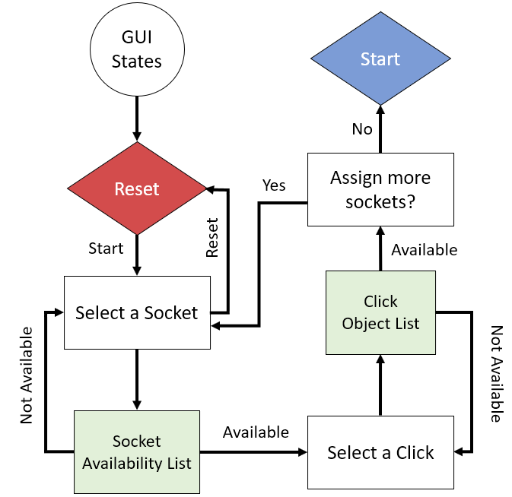

**Fig. 4.** How FRDM-KL46Z Mbed GUI handles Click and socket selection.

Towards the end of the semester some changes were made to the design that simplified the UART and SPI connections. In the past, the way UART was being handled was with a UART to SPI chip. Unfortunately, this proved to complicate the soldering and programming work too much for the project. As such, the UART to SPI IC was discarded and replaced with 4 straight connections to each of the UART channels on the FRDM-KL46Z. Doing this also freed up 2 Digital-Out pins that were used to get rid of the 2:4 decoder that was being used on SPI. Instead of a 2:4 decoder, the new board design simply has 4 select lines for each of the SPI connections in the MikroBUS sockets.

As for the synchronous aspect of the code, the 4 mikroBUS standard devices had to be constantly switching in a while loop created in the FRDM-KL46Z code for the Mbed compiler. The devices do not run simultaneously, but the switches from one device to the other can be as fast as the FRDM-Kl46Z can handle. Meaning it become dependent on the clock speed which can be overclocked if the user desires it. ***Fig. 5***. below shows how the FRDM-KL46Z code handles switching between Clicks once connected to the Click Sensor Hub board.

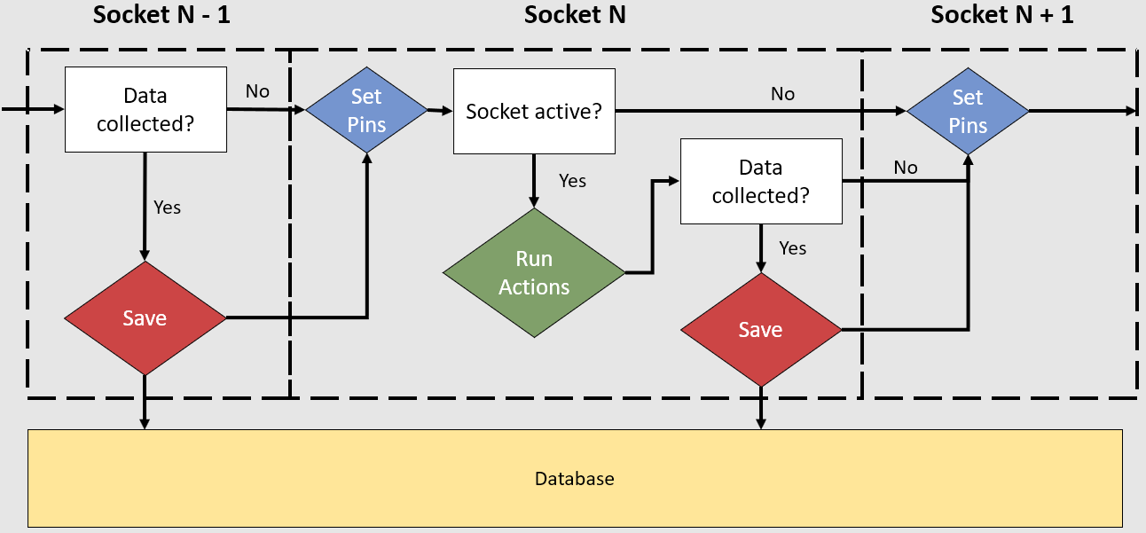

**Fig. 5.** Loop for FRDM-KL64Z to switch between the different Click Sensors attached to the Click Sensor Hub board. This is meant to approach a simultaneous behavior in which all the Clicks are running at the same time when the switches from one Click to the next

## Project Approach

The Click Sensor Hub project was broken up into two major milestones. The PCB and the FRDM-KL46Z code for the selected Clicks. There was also a stretch goal of making a website to gather all the necessary information to utilize the project. During the first semester focus was on getting the hardware aspect of the project finished. The Click Sensor Hub board ran through many iterations. Even when the design of the board was finalized, it still needed to be tested and the results of these tests resulted in the need for more iterations of the board.

The code for the clicks could be tested without the Click Sensor Hub board. This meant that progress on the code has been going on throughout all stages of the project. Additionally, the code for the Clicks can be worked on individually for each Click. This means throughout the project goals have been set for testing and validating each of the Clicks by certain dates. ***Fig. 6***. below displays how the FRDM-KL46Z interpreted the readings from the 4 MikroBUS standard sockets. It highlights how, from the KL46Z perspective, how many pins the code was dealing with.

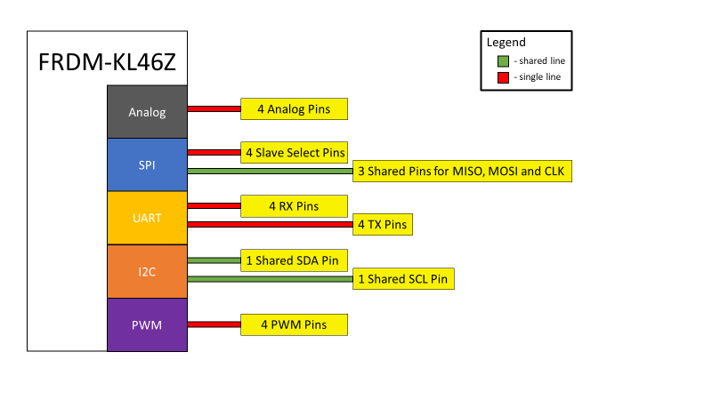

**Fig. 6.** FRDM-KL46Z pin readings from 4 MikroBUS standard sockets abstraction. The yellow boxes highlight all the pin assignments that were necessary for writing the code in the Mbed compiler.

Work on the website has been done mostly in the week the team waited for the PCB to arrive. At the end of the semester all the data was collected and placed in the correct tab. Links to GitHub and Eagle files were also made available.

## Engineering Standards

**Table 1.** Applicable Standards

|  |  |  |
| --- | --- | --- |
| **Title** | **Application** | **Relevance** |
| mikroBUS Standard | Four mikroBUS sockets on PCB | PCB Design |

## Progress Towards Goals

All initial goals have been completed. All necessary data has been recorded. All Clicks have been tested. The board has been tested. All that is left is to post Senior Design Day results to NXP forums as per the agreement with Dr. Kemp.

## Verification

All tests were performed by 2 or more teammates before being recorded into official documents. Tests on PCB boards were done on multiple boards (at least 1 board per teammate for every test and every iteration of the PCBs). Test for code was reset at least 3 times per test to confirm results. All code tests were performed on at least 2 different days with the same code to ensure correct results.

## Characterization Results

All results were document as specified above in section 5.6. In accordance with the standards set for this project, the results for the Individual Click Validation can be seen in ***Table 2*** and the results for the Click Sensor Hub Board Validation can be seen in ***Table 3***. Tests were generated in accordance to what was documented on the Test Plan and Functional Spec respectively. Finally, ***Table 4*** specifies the results for the Stretch Goal - Website Validation.

**Table 2.** Individual Click Validation. Detailing the test procedures and the respective results.

|  |  |  |  |
| --- | --- | --- | --- |
| Test Case | Test Specifications | Test Results | Compliance |
| Temp & Hum 2 Click | Board powered by 3.3V connection | Connected board and checked LED light. Measured | Pass |
| Ensure safe connection to FRDM-KL46Z, no feedback voltage should be above 3.3V | Voltages of respective pins measured to be below 3.3V threshold | Pass |
| Get temperature readings via FRDM-KL46Z code to display on PUTTY | Non-zero reading recorded and displayed on PUTTY | Invalid due to board being discontinued by Mikro |
| USB UART 3 Click | Board powered by 3.3V and 5V connections | Connected board and checked LED light. Measured | Pass |
| Ensure safe connection to FRDM-KL46Z, no feedback voltage should be above 3.3V | Voltages of respective pins measured to be below 3.3V threshold | Pass |
| Successful USB connection via USB UART 3 Click to FRDM-KL46Z | Established PUTTY connection via USB UART 3 Click | Fail |
| Color 5 Click | Board powered by 3.3V and 5V connections | Connected board and checked LED light | Pass |
| Ensure safe connection to FRDM-KL46Z, no feedback voltage should be above 3.3V | Voltages in respective pins measured to be below 3.3V threshold | Pass |
| Get RGB readings via FRDM-KL46Z code to display on PUTTY | Non-zero reading recorded and displayed on PUTTY | Fail |
| Bar Graph 2 Click | Board powered by 3.3V and 5V connections | Connected board and checked LED light | Pass |
| Ensure safe connection to FRDM-KL46Z, no feedback voltage should be above 3.3V | Voltages of respective pins measured to be below 3.3V threshold | Pass |
| Cycle Bar Graph Click through set pattern | Pattern set and displayed on Click | Pass |
| Accel 5 Click | Board powered by 3.3V connection | Connected board and checked LED light | Pass |
| Ensure safe connection to FRDM-KL46Z, no feedback voltage should be above 3.3V | Voltages of respective pins measured to be below 3.3V threshold | Pass |
| Get x, y, z coordinate acceleration readings from Click | Non-zero reading recorded and displayed on PUTTY | Fail |
| Gaussmeter Click | Board powered by 3.3V connection | Connected board and checked LED light | Pass |
| Ensure safe connection to FRDM-KL46Z, no feedback voltage should be above 3.3V | Voltages of respective pins measured to be below 3.3V threshold | Pass |
| Get x, y, z magnetic field readings from Click | Non-zero reading recorded and displayed on PUTTY | Pass |
| Light Ranger 3 Click | Board powered by 3.3V connection | Connected board and checked LED light | Pass |
| Ensure safe connection to FRDM-KL46Z, no feedback voltage should be above 3.3V | Voltages of respective pins measured to be below 3.3V threshold | Pass |
| Get distance readings from Click | Non-zero reading recorded and displayed on PUTTY | Pass |
| Alcohol Click | Board powered by 5V connection | Connected board and checked LED light | Pass |
| Ensure safe connection to FRDM-KL46Z, no feedback voltage should be above 3.3V | Voltages measured to be unsafe. Measured at 4.2 volts peak despite tweaking variable resistor to max value. | Fail, Click not safe to use |
| Get alcohol level reading from Click | Non-zero reading recorded and displayed on PUTTY using a resistor and a breadboard, not tested on Click Sensor Hub board due to damage it would cause FRDM-KL46Z | Invalid due to not being safe for board |
| Air Quality Click | Board powered by 3.3V and 5V connections | Connected board and checked LED light | Pass |
| Ensure safe connection to FRDM-KL46Z, no feedback voltage should be above 3.3V | Voltages of respective pins measured to be below 3.3V threshold | Pass |
| Get air quality level reading from Click | Non-zero reading recorded and displayed on PUTTY | Pass |
| microSD Click | Board powered by 3.3V connection | Connected board and checked LED light | Pass |
| Ensure safe connection to FRDM-KL46Z, no feedback voltage should be above 3.3V | Voltages of respective pins measured to be below 3.3V threshold | Pass |
| Get data from SD card to FRDM-KL46Z via Click board | Number value successfully read from text file | Pass |

**Table 3.** Click Sensor Hub Board Validation. Detailing the test procedures and the respective results.

|  |  |  |  |
| --- | --- | --- | --- |
| **Test Case** | **Test Specifications** | **Test Results** | **Compliance** |
| **Socket #1** |  |  | Pass |
| (AN) Analog | Test Analog Click on Socket | Putty output achieved on selected socket with Air Quality Click | Pass |
| (MISO/MOSI)  (CS/SCK) SPI | Test SPI Click on Socket | Bar Graph Click had selected pattern displayed on selected socket | Pass |
| (RX/TX) UART | Test UART Click on Socket | Serial connection on computer via selected socket | Pass |
| (SCL/SDA) I2C | Test I2C Click on Socket | I2C connection displayed data on PUTTY terminal using Temp2Hum Click via the selected socket | Pass |
| PWM | Test PWM Click on Socket | Bar Graph Click had selected pattern displayed on selected socket | Pass |
| (+3.3V/+5V) VCC/GND | All four mikroBUS™ sockets have both an optional 3.3V and 5V channel. All four mikroBUS™ sockets are grounded | When PCB is powered with 10v and 1amp. Both the +3.3V and +5V channels display proper voltage output. The GND has 0V output | Pass |
| **Socket #2** |  |  | Pass |
| (AN) Analog | Test Analog Click on Socket | Putty output achieved on selected socket with Air Quality Click | Pass |
| (MISO/MOSI)  (CS/SCK) SPI | Test SPI Click on Socket | Bar Graph Click had selected pattern displayed on selected socket | Pass |
| (RX/TX) UART | Test UART Click on Socket | Serial connection on computer via selected socket | Pass |
| (SCL/SDA) I2C | Test I2C Click on Socket | I2C connection displayed data on PUTTY terminal using Temp2Hum Click via the selected socket | Pass |
| PWM | Test PWM Click on Socket | Bar Graph Click had selected pattern displayed on selected socket | Pass |
| (+3.3V/+5V) VCC/GND | All four mikroBUS™ sockets have both an optional 3.3V and 5V channel. All four mikroBUS™ sockets are grounded | When PCB is powered with 10v and 1amp. Both the +3.3V and +5V channels display proper voltage output. The GND has 0V output | Pass |
| **Socket #3** |  |  | Pass |
| (AN) Analog | Test Analog Click on Socket | Putty output achieved on selected socket with Air Quality Click | Pass |
| (MISO/MOSI)  (CS/SCK) SPI | Test SPI Click on Socket | Bar Graph Click had selected pattern displayed on selected socket | Pass |
| (RX/TX) UART | Test UART Click on Socket | Serial connection on computer via selected socket | Pass |
| (SCL/SDA) I2C | Test I2C Click on Socket | I2C connection displayed data on PUTTY terminal using Temp2Hum Click via the selected socket | Pass |
| PWM | Test PWM Click on Socket | Bar Graph Click had selected pattern displayed on selected socket | Pass |
| (+3.3V/+5V) VCC/GND | All four mikroBUS™ sockets have both an optional 3.3V and 5V channel. All four mikroBUS™ sockets are grounded | When PCB is powered with 10v and 1amp. Both the +3.3V and +5V channels display proper voltage output. The GND has 0V output | Pass |
| **Socket #4** |  |  | Pass |
| (AN) Analog | Test Analog Click on Socket | Putty output achieved on selected socket with Air Quality Click | Pass |
| (MISO/MOSI)  (CS/SCK) SPI | Test SPI Click on Socket | Bar Graph Click had selected pattern displayed on selected socket | Pass |
| (RX/TX) UART | Test UART Click on Socket | Serial connection on computer via selected socket | Pass |
| (SCL/SDA) I2C | Test I2C Click on Socket | I2C connection displayed data on PUTTY terminal using Temp2Hum Click via the selected socket | Pass |
| PWM | Test PWM Click on Socket | Bar Graph Click had selected pattern displayed on selected socket | Pass |
| (+3.3V/+5V) VCC/GND | All four mikroBUS™ sockets have both an optional 3.3V and 5V channel. All four mikroBUS™ sockets are grounded | When PCB is powered with 10v and 1amp. Both the +3.3V and +5V channels display proper voltage output. The GND has 0V output | Pass |

**Table 4.** Stretch Goal Website Validation. Detailing the test procedures and the respective results.

|  |  |  |  |
| --- | --- | --- | --- |
| **Website Validation** | | | |
| **Test Case** | **Test Specifications** | **Test Results** | **Compliance** |
| Website hosted on Cloud Platform | Runs on Desktop or Mobile Platform via internet | Website successfully hosted on the Google Cloud Services | Pass |
| Website Content includes all necessary code and user files | A random user accessing the website must have access to all necessary documents | User can download code and hardware files from GitHub link to resources tab. | Pass |

## Deficiencies

The project deficiencies detected by the team were mostly improvements to the quality of life of anyone utilizing the Click Sensor Hub board. They are described in detail in ***Table 5*** below.

**Table 5.** System Deficiencies Accompanied by Suggest Solution and Estimated Completion Time

|  |  |  |  |
| --- | --- | --- | --- |
| Deficiency | Effect | Solution | Estimated Time for Solve |
| System does not detect high voltage levels coming from Clicks | FRDM-KL46Z board has potential to be damaged by Clicks | Integrate a system that regulates the output of the MikroBUS sockets | 3 months |
| Board operates with a variable power source | Difficult to people outside of a lab setting to utilize the Click Sensor Hub Board | Integrate battery or USB power to the board. | 2 months |
| Board not fully synchronous, the code must switch between each of the sockets at a specified speed | Clicks that require constant readings or instructions unable to function if more than 2 Clicks connected to the board utilized the same shared channels | Change design to serve a fully synchronous set of Click boards operating on shared channels | 12 months |

## Iterations and Redefinitions

From SOW:

*“The project is to work with the FRDM-KL46Z microprocessor board by NXP, create a Printed Circuit Board (PCB) that connects it to a minimum of 4 Clicks from MikroElektronika and write software that makes the board compatible with at least 10 Clicks. The purpose of the Clicks is to add functionality to Hexi-wear devices by NXP by expanding their sensor capabilities.”*

Most notable changes from what was initially written in the SOW is the shift in focus from Hexi-wear to an educational tool to be used in Dr. Stapleton’s Microprocessors class. The 4 Click minimum was met by the Click Sensor Hub board. The goal of testing 10 Click sensors was also met as described in section 5.7.

Most major iterations of the project happened when creating improvements on the Click Sensor Hub board. The dates in which these changes were made are described in ***Table 8*** in section 7 of this document. The first iteration of the board had the MikroBUS standard sockets on each of the four corners of the board, as can be seen in **Fig. 2**. The second iteration corrected this and placed the MikroBUS standard sockets on the right side as can be seen in **Fig. 1**. Finally, the third iteration got rid of a couple IC chips that were adding functionality but also complicated soldering and coding complexity. The third iteration is described in section 5.1. **Fig. 3**. displays the changes made in the third iteration in a graphical form.

# Constraints

## Budgetary

The limited budget constrained the design to a maximum of 10 Click Sensors purchased and a maximum of 2 layers on the PCB iterations.

## Design Feasibility

Right from the start, the team knew that it would not be possible to test the components that would be placed on the Click Sensor Hub board. As such, each of the Clicks and the FRDM-KL46Z was assumed to work at the specified characteristics on their technical documents. Additionally, all code written for the FRDM-KL46Z would have to be written on the free/online Mbed compiler. The team also recognized that any PCB that was design would have to be ordered from China at the cheapest price possible. This added the risk of receiving defective boards.

## Manufacturability

The PCB manufacturing had to be ordered through online providers due to the lab at Texas State University not having the necessary equipment to print out the board.

## Maintainability

The code written for the Click Sensor Hub board uses the Mbed library which is maintained by Mbed. As for the code for each individual Click, each of the functions was written for the IC contained in each click. The code for each of the Clicks requires no maintenance if the user is working the with the exact Click model specified in the Technical Spec.

## Environmental

The Click Sensor Hub project is not a source of any major environmental concerns. The only real physical product it provides is a PCB board. Any damage to the environment caused by the Click Sensor Hub project is equivalent to the environmental damage of printing out a PCB.

## Health and Safety

Depending on the click being used a person could be exposed up to 1A of current at a 10V maximum voltage. For this reason, it is recommended to take voltage values of pins a person is going to contact before connecting the FRDM-KL46Z or any of the Clicks.

## Social

The only constraints people would run into when trying to make use of the Click Sensor Hub board is a misunderstanding of where to connect the components so that they may communicate effectively. It is not recommended for anyone without previous knowledge of microprocessors to utilize the Click Sensor Hub board without instructions from a capable individual. It is very simple to fry the FRDM-KL46Z or any of the Clicks with incorrect current and voltage values or with incorrect soldering.

# Budgets

The total project budget for the Click Sensor Hub was $500.00 for both semesters. Both major parts orders can be seen in the following ***Table 6*** and ***Table 7*** below. Additionally, ***Table 8*** contains information of budget costs for each of the PCB orders.

**Table 6.** Parts Order January 25th, 2019

|  |  |  |  |  |  |
| --- | --- | --- | --- | --- | --- |
| **Vendor** | **Item Description** | **Part #** | **Quantity** | **Price Per** | **Total** |
| Digi-Key | 2:4 Decoder | SN74LVC1G139DCTR | 10 | $ 0.62 | $ 6.19 |
| Digi-Key | Interface Controller | SC16IS752IPW, 128 | 6 | $ 4.14 | $ 24.84 |
| Digi-Key | 8:3 Encoder | 296-33993-5-ND | 3 | $ 6.19 | $ 18.57 |
| MikroElektronika | Temp&Hum 2 Click | MIKROE-3085 | 1 | $ 16.00 | $ 16.00 |
| MikroElektronika | USB UART 3 click​ | MIKROE-3063 | 1 | $ 15.00 | $ 15.00 |
| MikroElektronika | Color 5 click ​ | MIKROE-3107 | 1 | $ 16.00 | $ 16.00 |
| MikroElektronika | BarGraph 2 Click ​ | MIKROE-3021 | 1 | $ 19.00 | $ 19.00 |
| MikroElektronika | Accel 5 click ​ | MIKROE-3149 | 1 | $ 19.00 | $ 19.00 |
| MikroElektronika | Gaussmeter click ​ | MIKROE-3099 | 1 | $ 19.00 | $ 19.00 |
| MikroElektronika | LightRanger 3 Click ​ | MIKROE-3103 | 1 | $ 24.00 | $ 24.00 |
| MikroElektronika | Alcohol Click | MIKROE-1586 | 1 | $ 15.00 | $ 15.00 |
| MikroElektronika | Air Quality Click ​ | MIKROE-1630 | 1 | $ 16.50 | $ 16.50 |
| MikroElektronika | microSD click | MIKROE-924 | 1 | $ 16.00 | $ 16.00 |
| Amazon | Tupperware for Storage | Sistema 1602 Klip It | 2 | $ 6.49 | $ 12.98 |
| Digi-Key | Diode gen | [CD1206-S01575](https://www.bourns.com/docs/Product-Datasheets/CD1206_S01575.pdf) | 10 | $ 0.15 | $ 1.52 |
| Digi-Key | Leaded resistor | MFR-25FBF52-52K3 | 10 | $ 0.08 | $ 0.80 |
| Digi-Key | Resistor US0805 | RMCF0201FT10K0TR-ND | 15 | $ 0.10 | $ 1.50 |
| Digi-Key | Capacitor 10uF | [CL21A106KQCLRNC](https://www.digikey.com/product-detail/en/samsung-electro-mechanics/CL21A106KQCLRNC/1276-2405-2-ND/3888063) | 15 | $ 0.11 | $ 1.65 |
| Digi-Key | Diode gen | 1727-3869-2-ND | 5 | $ 0.38 | $ 1.90 |
| Digi-Key | Indictor | SRN4018 | 10 | $ 0.40 | $ 4.03 |
| Digi-Key | Resistor 1k | ESR10EZPF1001 | 20 | $ 0.15 | $ 2.92 |
| Digi-Key | Capacitor 22uF | 1276-6687-1-ND | 20 | $ 0.13 | $ 2.56 |
| Digi-Key | Crystals 12MHz | 490-5581-1-ND | 10 | $ 0.29 | $ 2.90 |
| Spark Fun | Mini pushbutton switch |  | 5 | $ 0.95 | $ 4.75 |
|  |  |  |  | **TOTAL** | **$ 262.61** |

**Table 7.** Parts Order February 23rd, 2019

|  |  |  |  |  |  |
| --- | --- | --- | --- | --- | --- |
| **Vendor** | **Item Description** | **Part #** | **Quantity** | **Price Per** | **Total** |
| Digi-Key | ﻿LD2908 DC to DC | LD29080DT33R | **10** | $ 1.30 | $ 11.67 |
| Digi-Key | LM2734 AC to DC | LM2734YMK/NOPBCT-ND | 10 | $ 2.54 | $ 22.82 |
| Digi-Key | 22pF capacitor | package case 602 | 20 | $ 0.10 | $ 1.48 |
| Digi-Key | Capacitor 10nf | package case 602 | 10 | $ 0.10 | $ 0.61 |
| Digi-Key | Resistor 10 k ohm | package case 602 | 10 | $ 0.10 | $ 0.67 |
| Digi-Key | Resistor 52.3 k ohm | package case 602 | 10 | $ 0.35 | $ 3.00 |
| Digi-Key | Capacitor 10uF | package case 602 | 20 | $ 0.18 | $ 2.58 |
| Digi-Key | Crystals 12MHz | 5*3.2 4pads | 10 | $ 0.67 | $ 11.26 |
| Digi-Key | 8:3 Encoder | 300 *7,4 Through Hole | 10 | $ 0.43 | $ 3.71 |
| Digi-Key | Interface Controller | SC16IS752IPW, 128 | 4 | $ 4.14 | $ 16.56 |
| Digi-Key | Diode gen | 1727-3869-2-ND | 5 | $ 0.38 | $ 1.90 |
| Spark Fun | Mini pushbutton switch |  | 14 | $ 0.95 | $ 13.30 |
|  |  |  |  | **TOTAL** | **$ 89.56** |

**Table 8.** PCB Orders

|  |  |  |  |  |  |
| --- | --- | --- | --- | --- | --- |
| **Vendor** | **Item Description** | **Date** | **Quantity** | **Parts Cost** | **Shipping Cost** |
| HK WEIKU TECHNOLOGY | 2 Layer PCB | 02/01/2019 | 10 | $ 37.00 | $ 23.00 |
| JLCPCP | 2 Layer PCB | 02/10/2019 | 5 | $ 11.96 | $ 23.00 |
| JLCPCP | 2 Layer PCB | 03/29/2019 | 5 | $ 12.02 | $ 23.00 |
|  |  |  |  | **TOTAL** | **$ 129.98** |

# Work Schedule

The work schedule was made early in the first semester of the project and although the dates may have been pushed back or some of the tasks finished early, the progress was made overall in the order in which it was planned. ***Table 9*** below describes

**Table 9.** Click Sensor Hub work schedule timeline

|  |  |  |  |  |
| --- | --- | --- | --- | --- |
| **Task** | **Assigned to** | **Progress** | **Start** | **End** |
| Fall 2018 Deliverables |  | 100% | 9/10/18 | 1/22/19 |
| Set up SharePoint site. Organized necessary folders and uploaded relevant documents. | Alfonso | 100% | 9/10/18 | 9/12/18 |
| Gathered team suggestions into an easy to read format to present for our sponsors. | Dylan | 100% | 9/12/18 | 9/17/18 |
| Listed Sponsor Concerns in one concise document to discuss in meeting. | Mohamed | 100% | 9/12/18 | 9/17/18 |
| Set up GitHub and software for online meetings. | Alfonso | 100% | 9/12/18 | 9/17/18 |
| Outputting basic “Hello World” program on MBED compiler. | Dylan | 100% | 9/12/18 | 9/17/18 |
| Make a list of clicks that will be used for projects with reasoning. | Mohamed | 100% | 9/12/18 | 9/17/18 |
| Coordinate Hardcopy of Statement of Work | Alfonso | 100% | 9/10/18 | 9/24/18 |
| Begin Initial PCB Design complying with the mikroBUS standard | Mohamed | 100% | 9/24/18 | 9/30/18 |
| Begin initial Mbed library design at very high level | Dylan | 100% | 9/24/18 | 9/30/18 |
| Coordinate Hardcopy of Functional Spec | Alfonso | 100% | 9/25/18 | 10/15/18 |
| Initial Design PCB Finalized | Mohamed | 100% | 10/15/18 | 11/1/18 |
| Initial Design for MBED Interface Finalized | Dylan | 100% | 10/15/18 | 11/1/18 |
| Coordinate Initial Design Review Presentation | Alfonso | 100% | 10/15/18 | 10/23/18 |
| Coordinate Hardcopy Updated Spec | Alfonso | 100% | 10/22/18 | 11/5/18 |
| Order PCB to be printed | Mohamed | 100% | 10/20/18 | 11/15/18 |
| Design for Initial Website Layout | Alfonso | 100% | 11/1/18 | 12/1/18 |
| Coordinate Hardcopy of Labor Cost Schedule | Alfonso | 100% | 11/5/18 | 11/19/18 |
| Testing PCB | Mohamed | 100% | 11/15/18 | 12/1/18 |
| First Draft of Poster for Review | Mohamed | 100% | 11/12/18 | 11/26/18 |
| Coordinate Hardcopy of Test Plan | Alfonso | 100% | 11/16/18 | 11/30/18 |
| Second Design-Manufacturing Cycle for PCB | Alfonso | 100% | 12/1/18 | 1/15/19 |
| Winter Break | Team | 100% | 12/14/18 | 1/22/19 |
| Spring 2019 Deliverables |  | 100% | 1/16/19 | 5/20/19 |
| Complete Signal reading library with interface class using Mbed | Dylan | 100% | 1/16/19 | 2/16/19 |
| Full functionality test of I/O with 10 Clicks on functioning PCB | Mohamed | 100% | 1/16/19 | 2/16/19 |
| Initial Design for Website with HTML and CSS | Alfonso | 100% | 1/16/19 | 2/16/19 |
| Optimize Mbed code and test with all Clicks | Dylan | 100% | 2/16/19 | 3/29/19 |
| Gather sample data from Clicks | Mohamed | 100% | 2/16/19 | 3/29/19 |
| Implement Website Functionality | Alfonso | 100% | 2/16/19 | 3/29/19 |
| Full PCB and Clicks functionality test | Mohamed | 100% | 3/3/19 | 4/16/19 |
| Full Mbed code functionality test | Dylan | 100% | 3/3/19 | 4/16/19 |
| Full Website code functionality test | Alfonso | 100% | 3/16/19 | 4/16/19 |
| Full Project functionality test | Alfonso | 100% | 4/17/19 | 5/4/19 |
| Final Poster Review | Mohamed | 100% | 4/17/19 | 5/4/19 |
| Final Presentation Preparation | Dylan | 100% | 4/17/19 | 5/4/19 |
| Senior Design Day | Team | 100% | 5/5/19 | 5/5/19 |
| Post descriptions reports and source code in Mbed and NXP community forums | Alfonso | 100% | 5/6/19 | 5/9/19 |

# Personnel Interactions

## Teamwork

Working with microprocessors meant that the large task of completing the Click Sensor Hub Project was able to be split into many daily/weekly/monthly goals that all team members gave input on and contributed. However, there were major project milestones that each member was ultimately responsible for. They are as follows:

Alfonso:

* Activity and resource planning for meeting deadlines
* Document Full Functionality Test
* Mbed code to interfacing between board and sockets
* Stretch – Front/back end design for website
* Stretch – Manage cloud hosting for website

Dylan:

* Mbed code for interfacing between board and sockets
* Presentation, poster, user guide and T-Shirt design
* Document 10 Click Validation Test
* Stretch – Website Design (CSS/HTML)

Mohamed:

* PCB design/edits in Eagle CAD
* Document Hardware Functionality Test
* Soldering prototype boards
* Stretch – Instructional web articles for hardware usage/testing

## Mentorship

The Click Sensor Hub project owes many thanks to its faculty advisor at Texas State University, Dr. William Stapleton, and its Technical Mentor, Dr. Kevin Kemp. Without their continuous input throughout both semesters, the project would not be what it is today. Notably, Dr. Stapleton has met with team almost every Monday and Wednesday since the first semester to help guide our work of the week.

A good example of how Dr. Stapleton helps the project is he helped the team troubleshoot the Bar Graph Click for over an hour when the code was giving wrong results. At the end of the session the code had been worked out and all that was left was testing and validation.

A good example of how Dr. Kemp helps the project is he met with the team twice in the NXP offices to discuss the progress of the project and give us a small tour of the facilities to see how real-world companies handle similar projects. Dr. Kemp also always gives ample feedback on presentations and technical documents.

# Ethics

In accordance with the first guideline in the IEEE Code of Ethics this project maintained a focus on the “safety, health, and welfare of the public” by making sure test the design for any flaws that might have caused harm to a user of the product. It also provided “honest and realistic in stating claims or estimates based on available data” in all its documents.Of course, the team has not accepted any form of bribery or partaken in discrimination amongst any of its members (most of whom are foreigners).

The same statements discussed for the IEEE Code of Ethics apply for the NSPE Code of Ethics. In accordance with article I of the NSPE Code of Ethics, the Fundamental Canons, the team has created a safe to use product that looks out for “safety, health, and welfare of the public”. No one individual on the team has caused any environmental damage or otherwise that could suggest they have not conducted “themselves honorably, responsibly, ethically, and lawfully so as to enhance the honor, reputation, and usefulness of the profession”.

# Summary & Conclusions

It is the opinion of the Click Sensor Hub team that this project can be considered a success. Overall the team set out 3 major milestones and it accomplished them. A more detailed version of the of individual tests and results can be seen in ***Table 2***, ***Table 3*** and ***Table 4***. The major milestones of the project are listed below in ***Table 10*** as well the results of testing those milestones seen in ***Table 11***.

**Table 10.** Courses objectives as defined in the Statement of Work.

|  |  |
| --- | --- |
| **#** | **Objective** |
| 1 | Create a board that connects 1 FRDM-KL46Z to 4 MikroBUS standard sockets |
| 2 | Write necessary code for 10 different Clicks to interact with FRDM-KL46Z via the board created in the first objective |
| 3 | Power 4 simultaneous MikroBUS standard sockets via 3.3V and 5V channels provided by a power source that takes 10V/1A |
| 4 | Create a user guide that details how to implement and make changes to the project |
| 5 | Stretch Goal – Create cloud hosted website that compiles all the necessary project information in one place. |

**Table 11.** General tests and results of objectives described

|  |  |  |  |
| --- | --- | --- | --- |
| **Objective #** | **Test** | **Result of Requirements** | **Status** |
| 1 | Document Section 5.7, ***Table 3*** | All tests passed | Pass |
| 2 | Document Section 5.7, ***Table 2*** | 7/10 tests passed | Partial |
| 3 | Document Section 5.7, ***Table 3*** | All tests passed | Pass |
| 4 | Document Section 5.7, ***Table 4*** | All tests passed | Pass |
| 5 | Document Section 5.7, ***Table 4*** | All tests passed | Pass |

Overall, the project met all its critical requirements to be considered a success. Some of the Click did not meet preferred requirements but this was expected and planned for in advance. The results all met a desired level of accuracy and honesty in accordance with IEEE and NSPE Codes of Ethics. The Click Sensor Hub Team provided results that meet over 100% of the objectives due to meeting of Stretch Goals in addition to required goals.

# Discussion

## Academic Preparation

This project would have been near impossible without the years of knowledge acquired at Texas State University. Most notably the selected courses the team agreed helped the most can be seen below in ***Table 12***.

**Table 12.** Courses teammates agreed were most useful for completing the Click Sensor Hub project

|  |  |  |
| --- | --- | --- |
| **Course No.** | **Core knowledge** | **Specific knowledge incorporated by team** |
| EE 3350 (Electronics I) | Design and analysis of active devices and equivalent circuits | Useful for testing different connection points across design for correct voltage readings. |
| EE 3420 (Microprocessors) | Principles of operation and applications of microprocessors | Understanding of SPI, I2C, UART, Analog and PWM channels |
| EE 4352 (Introduction to VLSI Design) | Analysis and design of CMOS integrated circuits | Used in design of PCB to understand constraints and requirements |
| EE 4370 (Communications Systems) | Transmission of signals through linear systems, analog and digital modulation, and noise | Used for stretch-goal of website design. Knowledge helped with setup of Cloud hosted website. |

## Lessons Learned

Many lessons learned in resource as well as time management. Perhaps the most technical lessons learned are as follows:

* Testing of the Click boards should have been done sooner, perhaps in the first semester due to the fact the board did not need to be finished to test the code.
* When having issues with any chip manufactured by a large company, give them a call. They will have a technical support team willing to help you.
* Each teammate should have been given 1 or 2 Clicks at the most and they should have been responsible for all the added functions given to them.

## Soft Skills

The team learned as whole how to present their progress in front of a crowd of people. Over the course of the semester every member learned from what the instructors and other students though of their presentations and made changes to respond accordingly. One important lesson from this was explaining our project in simpler terms. Initially for presentation, the audience would give feedback that Clicks were confusing or that it was not very clear what the Click Sensor Hub project did. This was corrected progressively throughout both semesters.

## Schedule Deviations

The major deviation in the project was due to ordering the PCB to be shipped during Chinese New Year. The festivities delayed the PCB by over 2 weeks. In addition, once it arrived the team tested it and found that newer versions needed to be ordered.

## Staffing

Having one less team member than other teams affected productivity. In addition, a large part of the project was coding and only one member on the team was a Computer Engineer. The Computer Engineering major was also the project manager, so a lot of the coding work was being done by a person that already had his hands full most of the time. As for the PCB design, the team member in charge of that was very capable due to having prior experience but without that experience there is no coursework at Texas State University that would have prepared him. PCB design should, in our opinion, be taught at some point in the Electrical Engineering curriculum.

## Final Observations

If this project started again today, the PCB design would obviously be the last iteration that is currently being used. In addition, each team member would have been given at most 2 Clicks to work on. Most Clicks would have been SPI, Analog or PWM since those were the easiest to understand and operate.

# Acknowledgments

The authors wish to acknowledge Texas State University for providing a testing grounds for all calculations as well as many years of education and hard work that gave the authors the capacity to accomplish everything written down. In addition, special thanks to Dr. William Stapleton for providing guidance throughout all stages of the product. Additionally, special thanks to Dr. Kevin Kemp for also providing guidance and letting us meet with him at NXP offices. Without both individuals the project would not have what it is today.

# References

​[1] NXP, "FRDM-KL46Z," [Online]. Available: https://www.nxp.com/downloads/en/schematics/FRDM-KL46Z_SCH.pdf. [Accessed October 2018].

​[2] mikroElektronika, "mikrobus-standard-specification-v200," [Online]. Available: https://download.mikroe.com/documents/standards/mikrobus/mikrobus-standard-specification-v200.pdf. [Accessed October 2018].

​[3] NXP, "FRDM-KL46Z: Freedom Development Platform for Kinetis® KL3x and KL4x MCUs," NXP, [Online]. Available: https://www.nxp.com/support/developer-resources/evaluation-and-development-boards/freedom-development-boards/mcu-boards/freedom-development-platform-for-kinetis-kl3x-and-kl4x-mcus:FRDM-KL46Z. [Accessed October 2018].